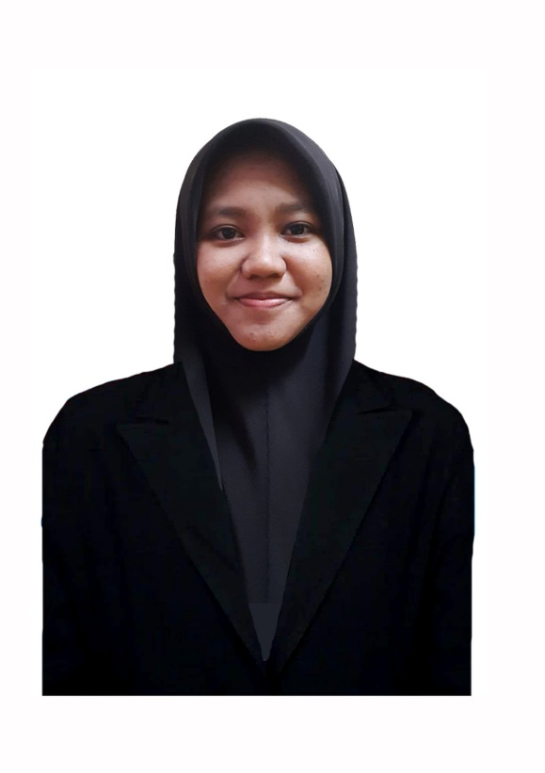IFFAH SYAHLIZA BINTI YAHYA



011-12945355

Iffahsyahz@gmail.com

Kuantan, Pahang

Iffah Syahliza Yahya

My principle life driven by a passion for exploration and continuous learning, I thrive on embracing new challenges and experiences. I believe that stepping out of my comfort zone and trying new things fosters personal and professional growth, increase creativity, and leads to innovative solutions. My commitment to lifelong learning and adaptability ensures that I am always evolving and contribute to others.

**Career Objective:** Experienced graphic designer with over 3 years of printing industry and a keen interest in transitioning to a UI/UX design role. Skilled in Adobe Photoshop, Adobe Illustrator and Figma. Eager to leverage my graphic design background and expand my skills in UI/UX design to contribute to innovative and user-friendly digital experiences.

Personal & Career Objective

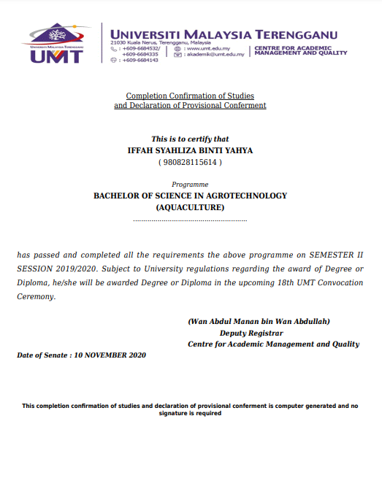

I am a dedicated professional with a background in Bachelor of Science in Agrotechnology Aquaculture and over three years of hands-on experience as a graphic designer in the printing industry. I have a strong passion for creativity, photography and continuous learning. I am eager to leverage my design expertise and continuous learning mindset to create impactful and innovative work.

**Professional skills:** Skilled in Adobe Photoshop, Adobe Illustrator, Figma, Canva, Capcut and Photography. Adaptability and eagerness to learn new tools and technologies.

About

|  |  |  |  |
| --- | --- | --- | --- |
| Company | Industries | Area | Position |
| Teamon Malaysia | Skincare | Digital Marketing | Video Editor |
| Limiteez, Kuantan | Printing | Manufacturing  Sector | Graphic Designer |
| JP Printing & Advertising, Kuantan | Printing | Manufacturing  Sector | Graphic Designer |
| Nisa Indera Mahkota, Kuantan | NGO | IT & Media | Graphic Designer |

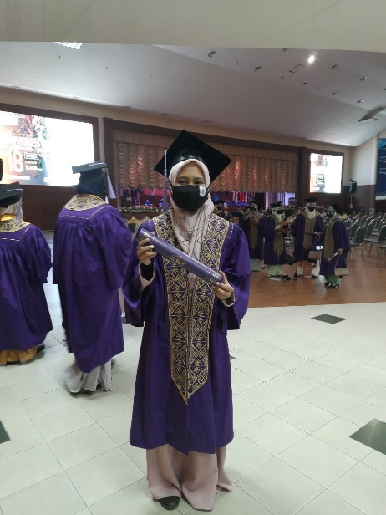

Experiencesctive

**NGO Nisa’ Kawasan Indera Mahkota | Team Media**

*2021 - present*

Key responsibilities:

* Create and manage content for social media platforms, including posts, videos, and graphics.
* Serve as the primary photographer for NGO events, capturing high-quality images.
* Manage and maintain photography equipment, ensuring readiness for events.
* Assist in the setup and operation of live streaming and recording equipment.

**JP Printing & Advertising |  Graphic Designer**

*October 2020 - March 2021*

Key responsibilities:

* Was responsible for designing brochures for products and services, including banners, posters, flyers, name cards, stickers, and signage.
* Adjusted and set up printing machines according to the orders.
* Greeted and assisted customers, received print orders and helped.

**Limiteez Pod Solution | Graphic Designer**

*April 2021 - April 2024*

Key responsibilities:

* Designed various marketing materials, posters, social media postings, and other promotional materials.
* Redesigned customer's logo and designed sublimation t-shirts.
* Prepared and adjusted artwork files for printing (customer's design DTF printing)
* Managed product listings, descriptions, and pricing in WooCommerce.Prepared material for social media content.
* Prepared material for social media content and edited video tutorials and TikTok videos.

**Teamon Malaysia | Video Editor**

*January 2024 - March 2024 ( Contract )*

Key responsibilities:

* Edited simple videos for TikTok, ensuring engaging and high-quality content.

Resilience and Success Stories

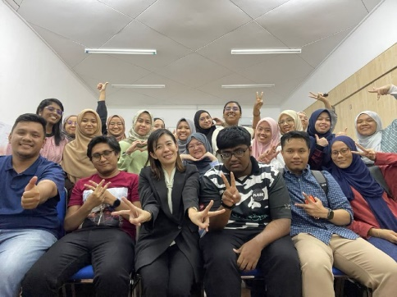

Education and Background

|  |  |  |  |
| --- | --- | --- | --- |
| Education | Majoring | Completion | Institute |
| Bachelor | Agrotechnology Aquaculture | 2017-2020 | Universiti Malaysia Terengganu |
| Foundation | Science Stream | 2016-2017 | Pahang Matriculation Collage |
| SPM | Science Stream | 2011-2015 | SMK Pelabuhan |

|  |  |  |
| --- | --- | --- |
| Organizer | Year | Training |
| The Future Talent by PEOPLElogy | July 2024 - August 2024 | Bootcamp IT (UI/UX Design) |
| MDEC | May 2020 | eUsahawan Online Learning with Coach Syahril |
| Tarbiyah Kreatif | July 2019 | Bengkel Grafik Adobe Illustrator |

|  |  |  |  |
| --- | --- | --- | --- |
| Company | Contact Number | Name | Position |
| Limiteez | References available upon  request | Eddie Tan | Manager Limiteez |
| JP Printing & Adverstising | Encik Wan Nazri | Manager JP Printing |
| Nisa Indera Mahkota | Puan Nuraini Tahir | President Nisa’ Kawasan Indera Mahkota |
| Universiti Malaysia Terengganu |  | DR. Nurul Aqilah | Lecturer, UMT |

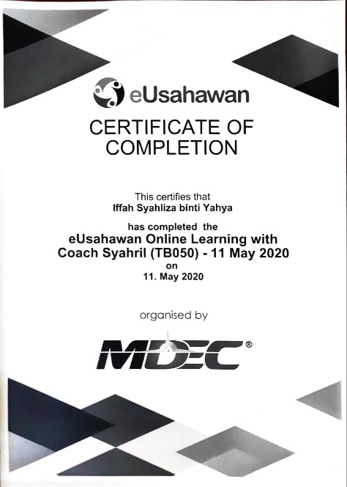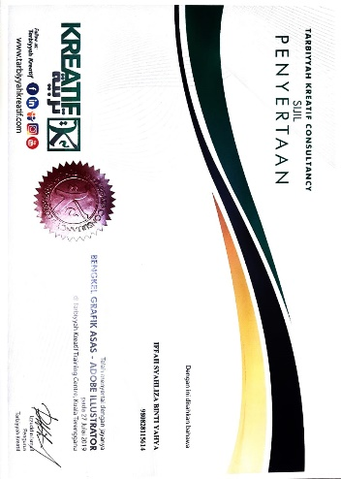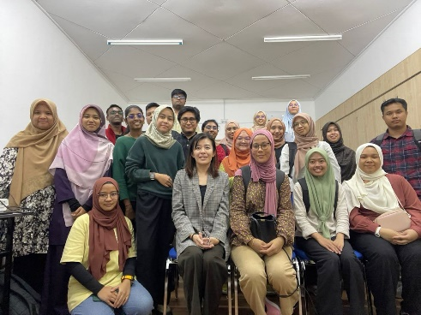

References & Testimonial

Training